# Backtest a Trend-Following Strategy

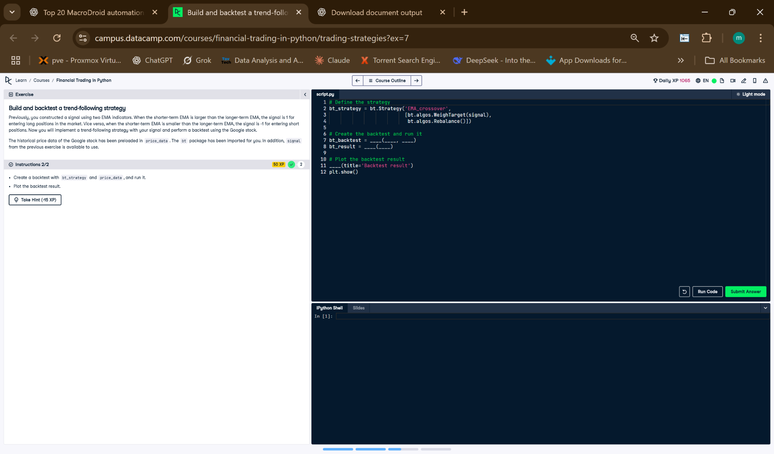

## Python Code

# Define the strategy  
bt_strategy = bt.Strategy('EMA_crossover',  
 [  
 bt.algos.WeighTarget(signal),  
 bt.algos.Rebalance()  
 ])  
  
# Create the backtest and run it  
bt_backtest = bt.Backtest(bt_strategy, price_data)  
bt_result = bt.run(bt_backtest)  
  
# Plot the backtest result  
bt_result.plot(title='Backtest result')  
plt.show()

## Explanation (50 Words)

This script runs a backtest using an EMA crossover trading strategy. It uses the signal created earlier to decide how much to invest and when to rebalance. The strategy is tested on stock data using bt.Backtest, and bt.run() executes it. Finally, it plots the results showing profits and performance over time.